G.I. Joe Toys - Night Landing (Cobra)
made by Pieter Steyn
web: http://maxandmaya.ueuo.com
e-mail: mayamodels@yahoo.com
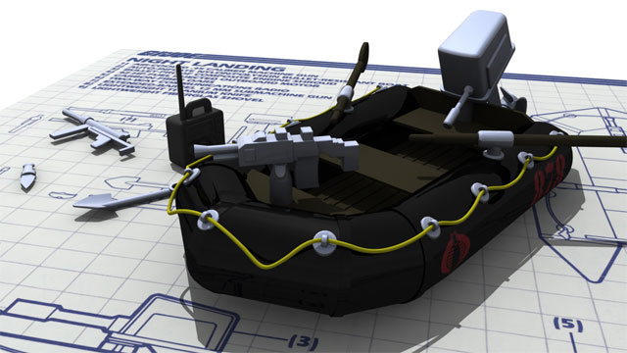
Model Detail:
Model format: Maya 2008 (*.mb / *.ma)  Total Number of Verts:  Total Number of Edges:  Total Number of Polygons:  Total Number of Polygons (Triangulated):  Total Number of UV’s: | 27510  53880  26468  54038  37885 | 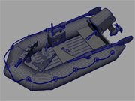

Model Description:
Engine:  Interior:  Opening Doors:  Textures: | Yes  Yes  N/A  Yes | 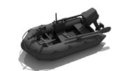
Comments:
Please feel free to e-mail me with any comments / questions regarding any model you have downloaded.
You can also make a request for model/s that you need.
Please submit your rating for the downloaded model.
Search for more models by typing in “copycatz” in the search bar at www.turbosquid.com

